# Bibliography

Australian Inflation | Chart Pack. (2020). Retrieved 15 October 2020, from <https://www.rba.gov.au/chart-pack/aus-inflation.html>

Choudhury, S. (2020). Australia's growth outlook dims as China's momentum falters amid coronavirus outbreak. Retrieved 17 September 2020, from <https://www.cnbc.com/2020/02/27/coronavirus-outbreak-australia-economic-impact.html>

From computer games to building supermarkets — this business shows the problems in our 'pivot' to manufacturing. (2020). Retrieved 11 October 2020, from <https://www.abc.net.au/news/2020-04-19/scott-morrison-government-coronavirus-covid19-manufacturing/12153568>

(2020). Retrieved 15 October 2020, from <https://www.health.gov.au/news/financial-support-for-aged-care-providers-directly-impacted-by-covid-19>

Janda, M. (2020). RBA expects 1 million Australians to stay unemployed until end of next year. Retrieved 15 October 2020, from <https://www.abc.net.au/news/2020-05-05/almost-one-million-australians-lose-jobs-due-to-coronavirus/12215494>

As universities face losing 1 in 10 staff, COVID-driven cuts create 4 key risks. (2020). Retrieved 15 October 2020, from <https://theconversation.com/as-universities-face-losing-1-in-10-staff-covid-driven-cuts-create-4-key-risks-147007>

McDermott, D. (2020). What impact has the coronavirus pandemic had on healthcare employment? - Peterson-KFF Health System Tracker. Retrieved 15 October 2020, from <https://www.healthsystemtracker.org/chart-collection/what-impact-has-the-coronavirus-pandemic-had-on-healthcare-employment/#item-year-over-year-change-in-healthcare-and-non-healthcare-employment-january-1991-through-may-2020>

Bonyhady, N., & Foley, M. (2020). Manufacturing shake-up to drive jobs boom: COVID taskforce. Retrieved 15 October 2020, from <https://www.smh.com.au/politics/federal/manufacturing-shake-up-to-drive-jobs-boom-covid-taskforce-20200729-p55gji.html>

Sullivan, K. (2020). 'We couldn't get people off the couch': Farm worker shortage looms despite rising unemployment. Retrieved 15 October 2020, from <https://www.abc.net.au/news/rural/2020-07-30/farm-labour-shortage-feared-due-to-coronavirus-controls/12504802>

# Research

## General

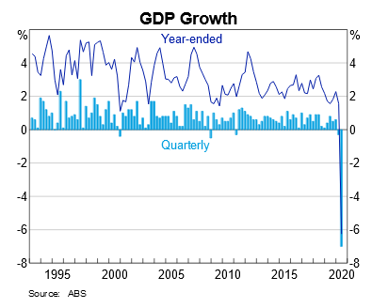

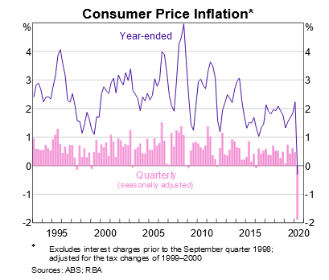Australian GDP in July 2020: -7%

UE in August 2020: 6.8%

## Agriculture & Mining

* (ABC) Before the pandemic there were 140k backpackers with working VISAs in Australia, now 85k
* China’s demand for iron ore and coal decreased as most manufacturing factories in China are idle currently
  + Hence decrease in X
  + Decrease in X means decrease in AD and hence reduction in EG
  + Decrease in demand means decrease for worker’s labour and hence UE increased
* (Deloitte) Iron ore is one of those commodities seen to be most at risk of major disruption. About 60% of the world’s seaborne iron ore is produced in the Pilbara
* Demand for primary resources decreased, DD decreased
  + Hence GPL decreased and hence deflation
* 1.2b wage subsidy, increased resource allocation
  + Up to 100k apprenticeships in mining industry

## Manufacturing

* Initially decreased due to pandemic then grew due to less imports from overseas, so economy was forced to produce domestically
* Gov injected 1.5b into manufacturing industry
  + Hence increase in G
* (SMH) Predicted that manufacturing industry can grow to create 495k new jobs in the next decade due to gov’s efforts to boost industry due to COVID-19
* Production of PPE and toilet paper increased, many companies switching over to this specific manufacturing
  + SS curve shifted right due to higher levels of production
* C increases due to increase in DD of goods manufactured domestically, especially healthcare products
  + Hence AD rises and there is an increase in EG
  + Increased demand also caused increase in GPL and hence inflation
  + Initial increase in UE but then fell due to jobs created by gov
  + Many high income or high skill workers are kept in jobs whereas lower workers become unemployed easily, therefore income dist. decreased as higher pay gap

## Healthcare

* (healthsystemtracker.org) employment decreased 7.8% in April 2019 to April 2020
  + Higher skilled workers kept in industry while lower skilled workers lose their jobs, hence decrease in income dist.
* DD increased for healthcare products and hence C increased
  + Causing increase in AD and hence EG
* Price of healthcare products rose due to price gouging and hence increase in GPL meaning inflation
  + Also meaning resources are not allocated properly

## Tourism & Hospitality

* In Jan-May 2019, 3.83m visitors to country, in Jan-May 2020, 1.8m
* (ABC) One third of jobs in tourism/hospitality industry lost during COVID-19 pandemic
  + Hence increase in UE, decrease in income dist.
* DD decreased due to restrictions put in place by government
  + Decrease in X and M (from tourism) and hence decrease in EG
  + Decrease in C (for hospitality) also lead to decrease in EG
  + In response to decrease in C, SS curve shifted left and hence decrease in AS

## Education

* (The Conversation) universities risk losing 1/10 staff
  + General increase in UE
  + Hence decrease in income dist.
  + High skilled workers in universities are being kept in the industry and are still being paid and hence inefficient allocation of resources
* Many universities have cut teacher’s pay to achieve more efficient allocation of resources
* Decrease in X and M so decrease in EG due to borders being closed
  + Also decrease in AD
* Lack of education will also lead to a higher pay gap (hence decreased income dist.)
* Government subsidies given to universities despite them having less students
  + Inefficient allocation of resources